


What is the A*STARS Programme?

The Active Sustainable Travel And Road Safety (A*STARS) programme was developed in Walsall in 2009 to help reduce congestion around school gates, provide opportunities for road safety training and education and to help keep Walsall children and their families safer and healthier.
In September 2013 your child’s school joined the programme.
What does this mean for me, my school and my child?
Your school will get lots of support from the Road Safety and Sustainable Travel Team at Walsall Council offering initiatives such as:
- Bikeability Training (the old Cycle Proficiency) for Year 6 children.
- Parent and child Reception Walks with a Road Safety Officer to talk about key road safety issues
- Practical roadside Pedestrian Training for Year 3 children
- Scooter training for children, teaching them about safe scooting
- Classroom based road safety sessions to raise awareness of the importance of both in-car safety such as wearing seat belts and road-side safety e.g. wearing a cycle helmet.
As parents/carers you may be invited to take part in road safety training or to accompany your child on initiatives promoting walking, cycling and scooting. You will also be encouraged to park away from school to help reduce pollution and congestion around the school and to give you and your child an opportunity to exercise together.
You will be hearing more about the programme over the next few months and you can find out more for yourself by looking at our new website when it is officially launched in the new academic school year.
Please contact Miss Treasure (your school A*STARS Co-ordinator) for more information.


Dear parents/careers,
As part of the A*STARS programme that our school has joined we will be taking part in a ’Let’s Walk Together’ event on Thursday 17th July. This is a one off initiative that you are invited to, to walk together with your child/ren along a predetermined route to school with other parents and staff members.
We will be meeting at the local Morrisons supermarket on Wallows Lane, by the bus stop near the back of the car park at 8:10 to then leave at 8:15.
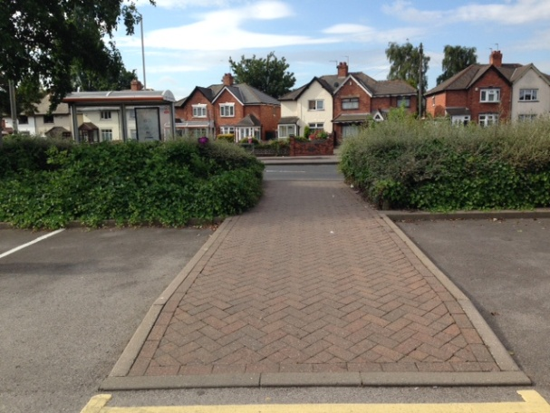

We aim to arrive at school approximately 8:30 where we will hold a short coffee morning providing refreshments for both children and parents/careers who take part in the walk. During this time a gift for participating can be collected.
Thank you for your support in advance and hope to see you there.
Miss Treasure
A*STARS Co-ordinator

